Adding a category

Most people organize their courses by department and college or by topic. Be sure to test the organizational scheme with a few users before entering a large number of courses, to save time in moving them later.

Adding categories is very simple:

* Go to *Administration > Site administration > Courses > Add a category*
* Complete the details required and click 'Create category.'
* Alternatively, you can go to *Administration>Site administration>Courses>Manage courses and categories* and click the link 'Create new category'.

[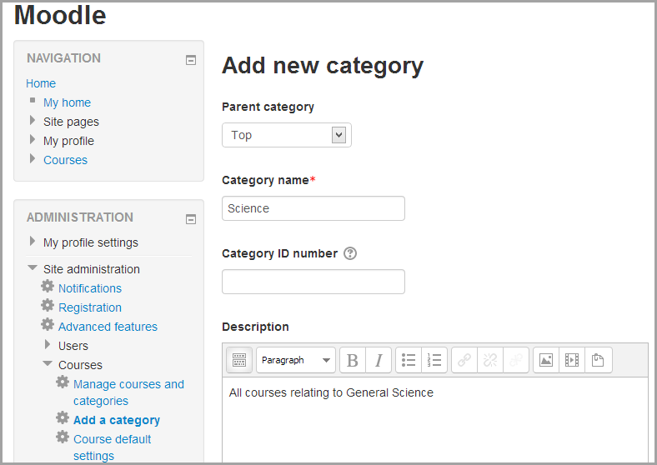](https://docs.moodle.org/31/en/File:Addcategory.png)

If the category is visible, the course category description will be displayed to users when they enter the category, above the list of courses.